**Evidence Gathering Document for SQA Level 8 Professional Developer Award.**

This document is designed for you to present your screenshots and diagrams relevant to the PDA and to also give a short description of what you are showing to clarify understanding for the assessor.

Each point that required details the Assessment Criteria (What you have to show) along with a brief description of the kind of things you should be showing.

Please fill in each point with screenshot or diagram and description of what you are showing.

**Week 2**

| Unit | Ref | Evidence |  |
| --- | --- | --- | --- |
| I&T | I.T.5 | Demonstrate the use of an array in a program. Take screenshots of:  *An array in a program  *A function that uses the array  *The result of the function running | |
|  |  | **Description:** | |

**Paste Screenshot here**

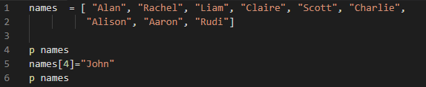

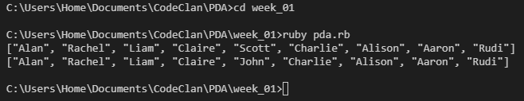

**Description here**

**Scott was changed to John using the function: names[4] = “John”**

**This finds the index position 4 (the index starts from 0) and updates it.**

| Unit | Ref | Evidence |  |
| --- | --- | --- | --- |
| I&T | I.T.6 | Demonstrate the use of a hash in a program. Take screenshots of:  *A hash in a program  *A function that uses the hash  *The result of the function running | |
|  |  | **Description:** | |

**Paste Screenshot here**

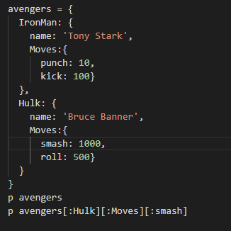

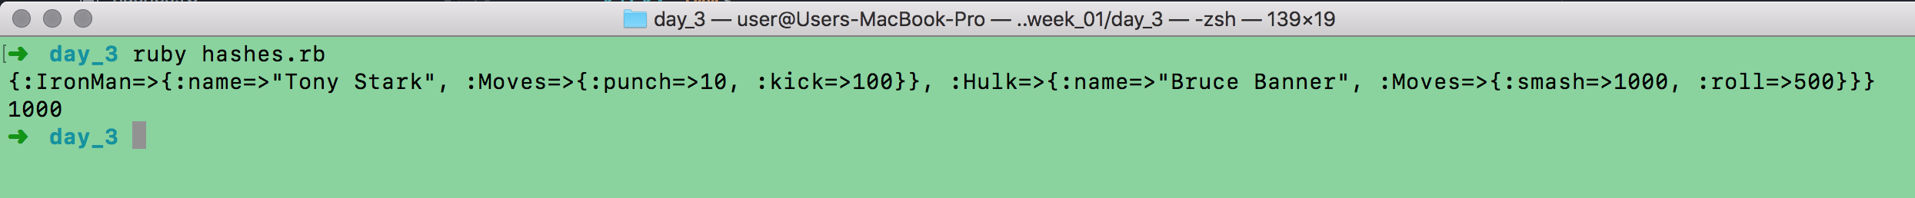

**Description here**

**The hash contains 2 avengers, their name and their moves. Using function: avengers[:Hulk][:Moves][:smash] returns the value of the Hulks smash which is 1000.**

**Week 3**

| Unit | Ref | Evidence |  |
| --- | --- | --- | --- |
| I&T | I.T.3 | Demonstrate searching data in a program. Take screenshots of:  *Function that searches data  *The result of the function running | |
|  |  | **Description:** | |

**Paste Screenshot here**

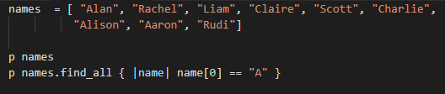

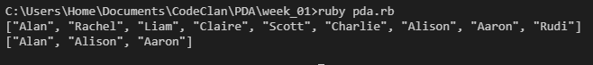

**Description here**

**The names array contains 9 names and by using the function: names.find_all { |name| name[0] == "A" } it searches the array and returns all the names beginning with A.**

| Unit | Ref | Evidence |  |
| --- | --- | --- | --- |
| I&T | I.T.4 | Demonstrate sorting data in a program. Take screenshots of:  *Function that sorts data  *The result of the function running | |
|  |  | **Description:** | |

**Paste Screenshot here**

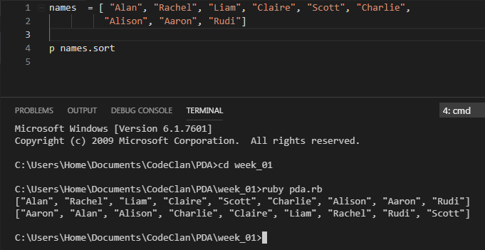

**Description here**

**We have a names array and by using the function: names.sort, we sort the names array into alphabetical order**

**Week 5 and 6**

| Unit | Ref | Evidence |  |
| --- | --- | --- | --- |
| A&D | A.D.1 | A Use Case Diagram | |
|  |  | **Description:** | |

**Paste Screenshot here**

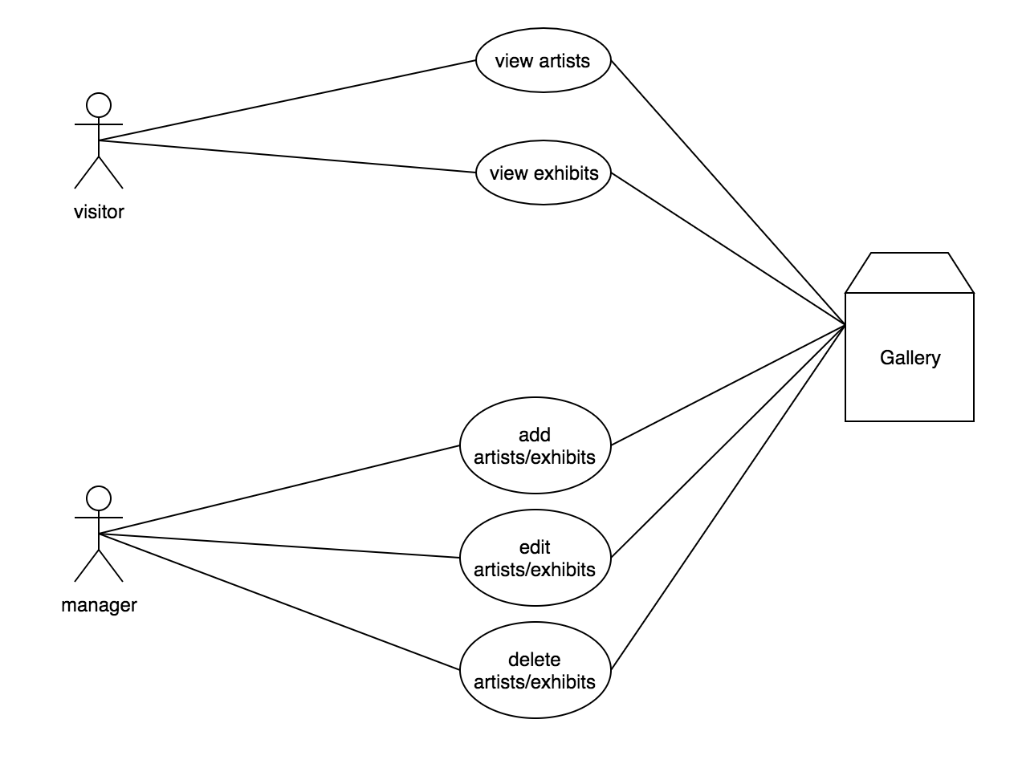

**Description here**

**This is the case diagram from my Ruby project. Its shows what is required for a visitor and a manager.**

| Unit | Ref | Evidence |  |
| --- | --- | --- | --- |
| A&D | A.D.2 | A Class Diagram | |
|  |  | **Description:** | |

**Paste Screenshot here**

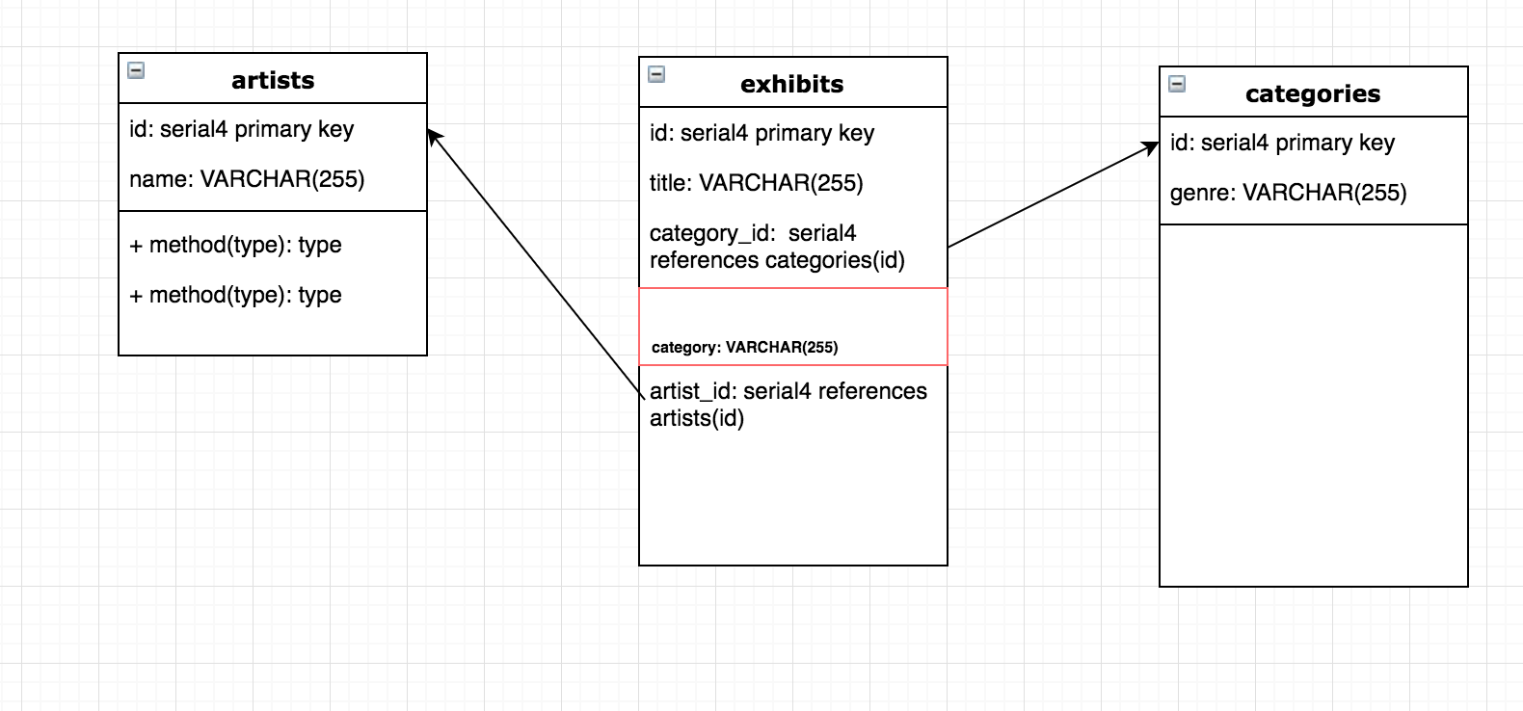

**Description here**

Classdiagram for Museum web app where exhibits have an artist who created it and a category it belongs to

| Unit | Ref | Evidence |  |
| --- | --- | --- | --- |
| A&D | A.D.3 | An Object Diagram | |
|  |  | **Description:** | |

**Paste Screenshot here**

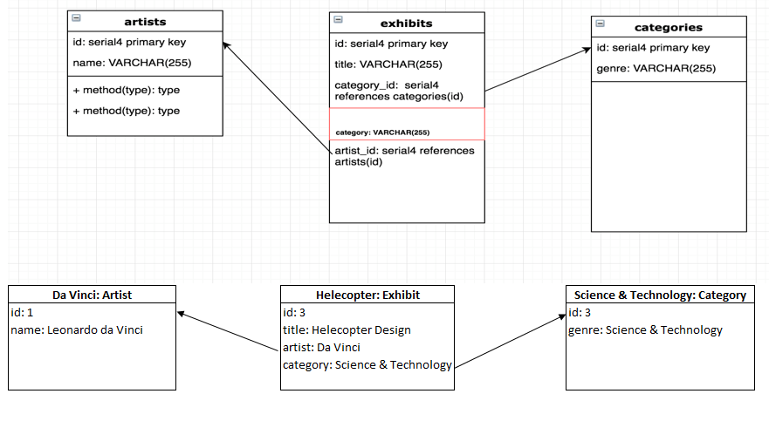

**Description here**

**This is the object diagram from the Museum project and it shows which category the exhibit belongs to and the artist who created it.**

| Unit | Ref | Evidence |  |
| --- | --- | --- | --- |
| A&D | A.D.4 | An Activity Diagram | |
|  |  | **Description:** | |

**Paste Screenshot here**

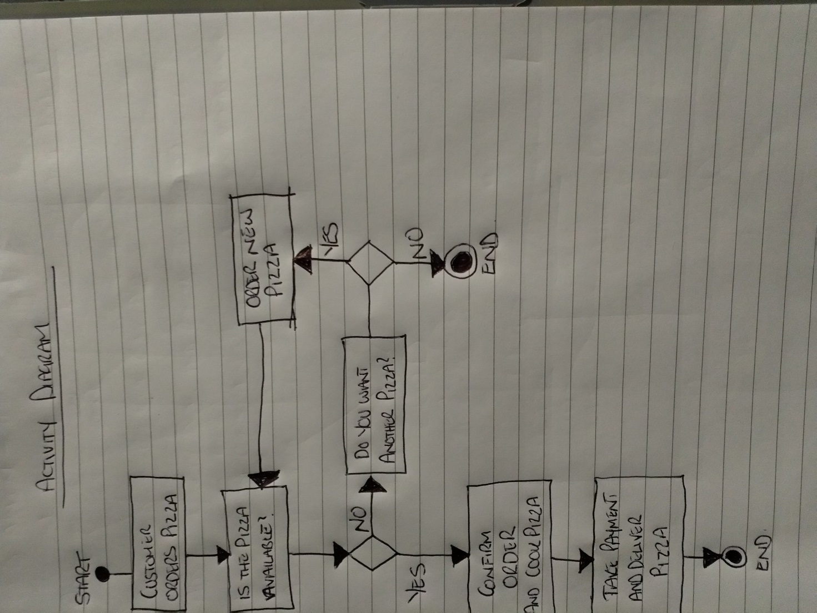

**Description here**

An activity diagram for the Pizza shop showing the interaction between the customer and the shop

| Unit | Ref | Evidence |  |
| --- | --- | --- | --- |
| A&D | A.D.6 | Produce an Implementations Constraints plan detailing the following factors:  *Hardware and software platforms  *Performance requirements  *Persistent storage and transactions  *Usability  *Budgets  *Time | |
|  |  | **Description:** | |

**Paste Screenshot here**

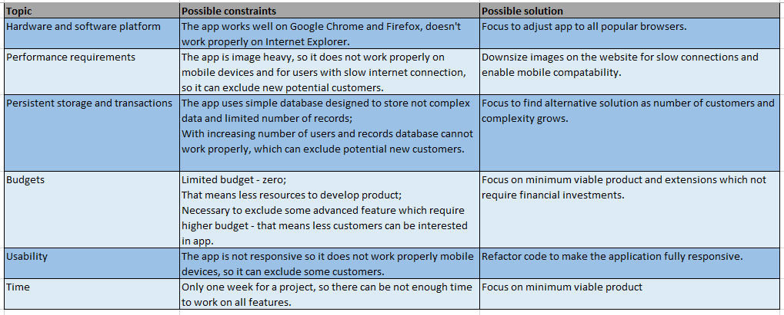

**Description here**

Plan that considers the constraints that a Museum app could have for its development.

| Unit | Ref | Evidence |  |
| --- | --- | --- | --- |
| P | P.5 | User Site Map | |
|  |  | **Description:** | |

**Paste Screenshot here**

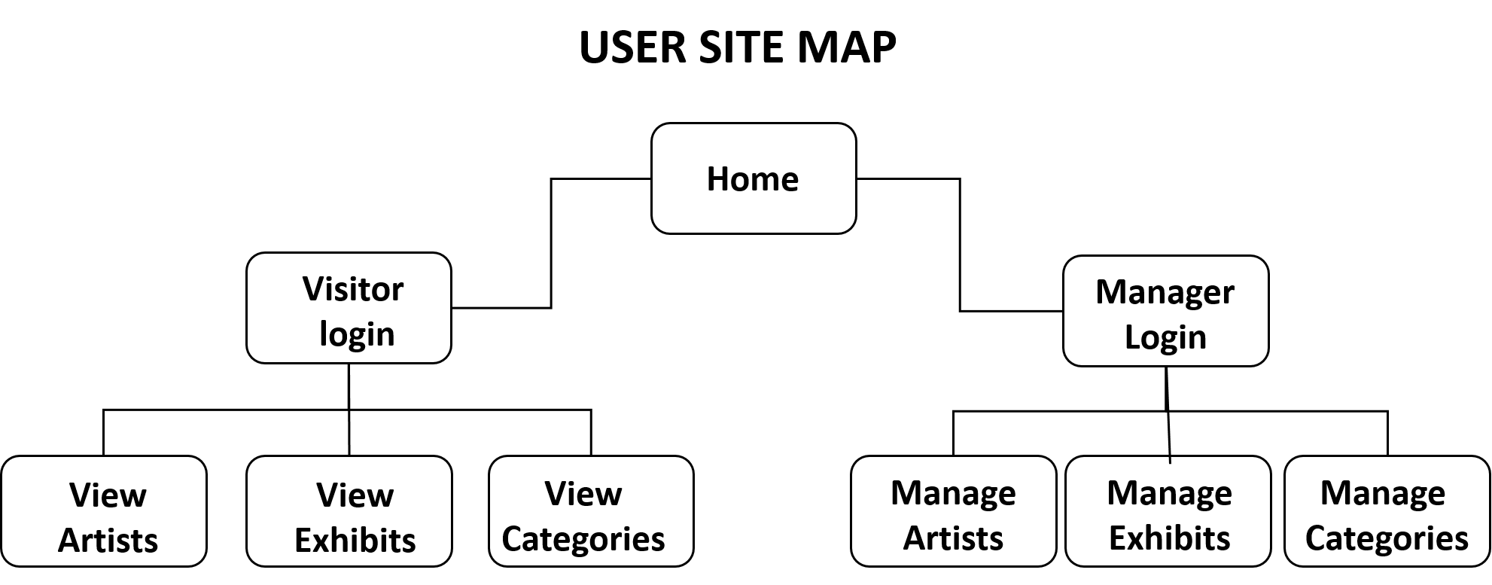

**Description here**

**The diagram shows a user site map of the museum app.**

| Unit | Ref | Evidence |  |
| --- | --- | --- | --- |
| P | P.6 | 2 Wireframe Diagrams | |
|  |  | **Description:** | |

**Paste Screenshot here**

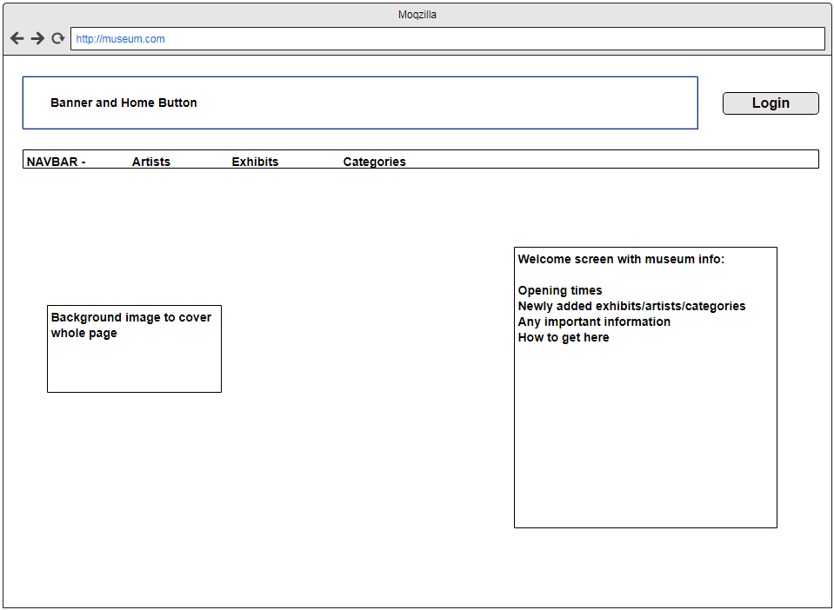

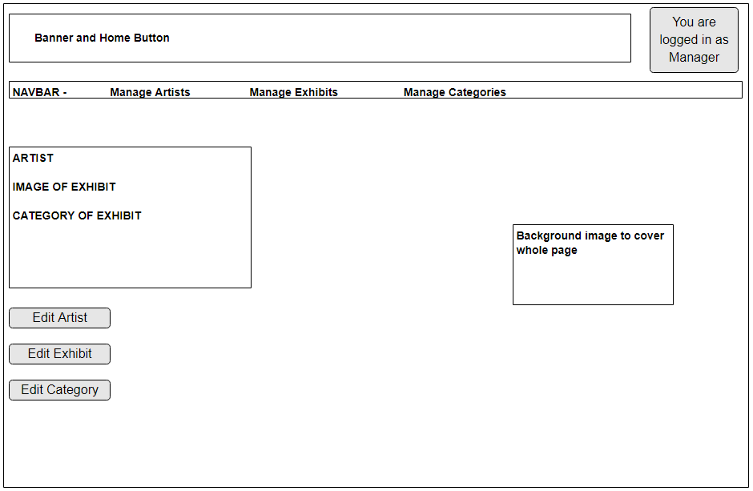

**Description here**

**The first diagram show the home screen of the app and the second diagram show the manager logged in and can now manage and edit.**

| Unit | Ref | Evidence |  |
| --- | --- | --- | --- |
| P | P.10 | Example of Pseudocode used for a method | |
|  |  | **Description:** | |

**Paste Screenshot here**

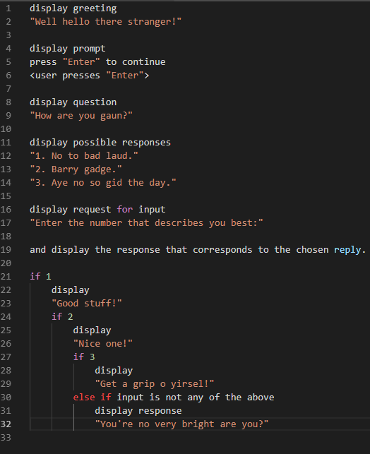

**Description here**

This program will request a response from the user.

If the response matches a specific response from the list, the response will be delivered;

If not, a rejection will be delivered.

| Unit | Ref | Evidence |  |
| --- | --- | --- | --- |
| P | P.13 | Show user input being processed according to design requirements. Take a screenshot of:  * The user inputting something into your program  * The user input being saved or used in some way | |
|  |  | **Description:** | |

**Paste Screenshot here**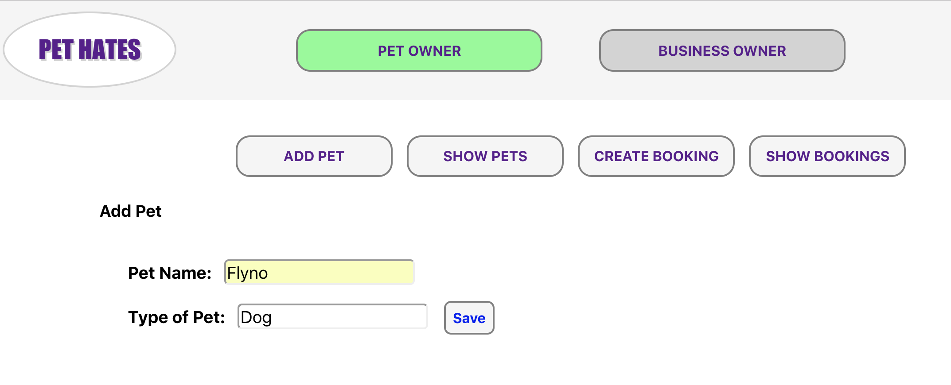

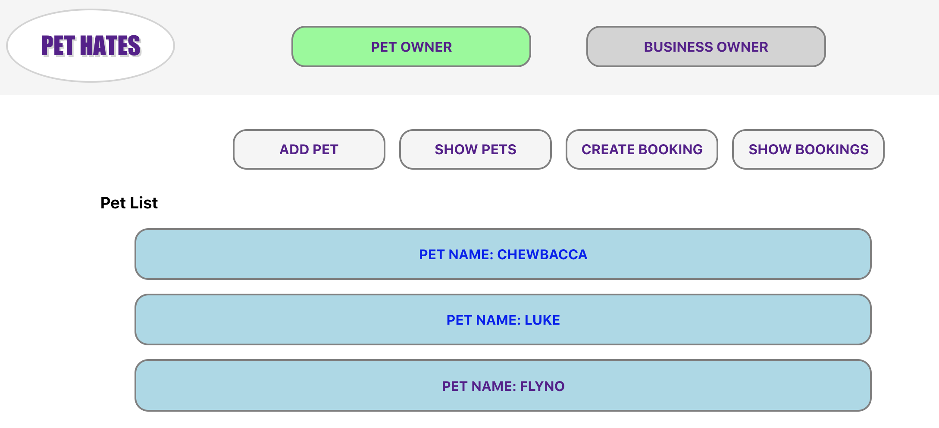

**Description here**

Pet owner adding a new pet on the Pet App. The 2nd screenshot shows the new pet added to the list of pets.

| Unit | Ref | Evidence |  |
| --- | --- | --- | --- |
| P | P.14 | Show an interaction with data persistence. Take a screenshot of:  * Data being inputted into your program  * Confirmation of the data being saved | |
|  |  | **Description:** | |

**Paste Screenshot here**



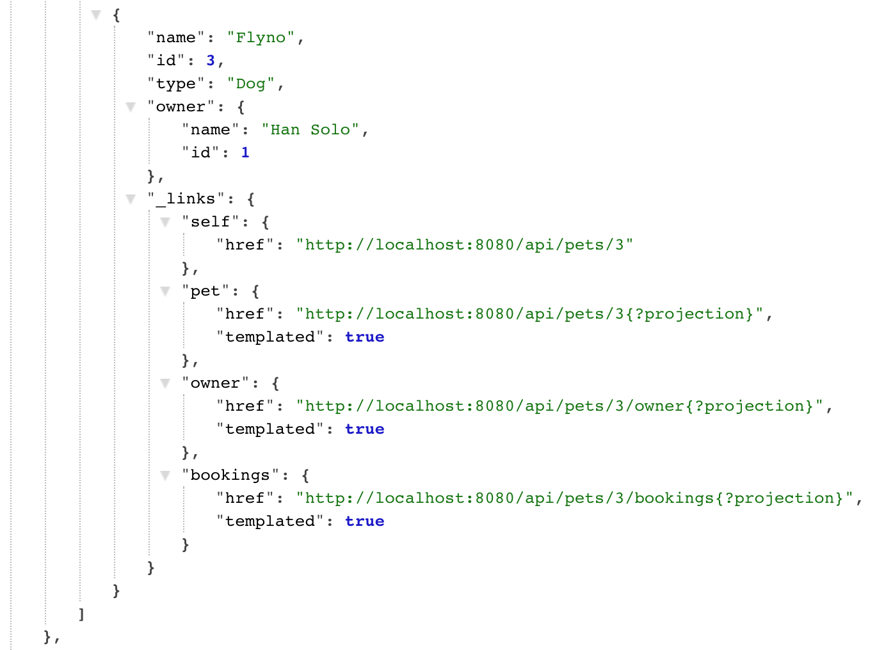

**Description here**

A pet owner adds a new pet in the first screenshot and the second shows it has been added to the API.

| Unit | Ref | Evidence |  |
| --- | --- | --- | --- |
| P | P.15 | Show the correct output of results and feedback to user. Take a screenshot of:  * The user requesting information or an action to be performed  * The user request being processed correctly and demonstrated in the program | |
|  |  | **Description:** | |

**Paste Screenshot here**

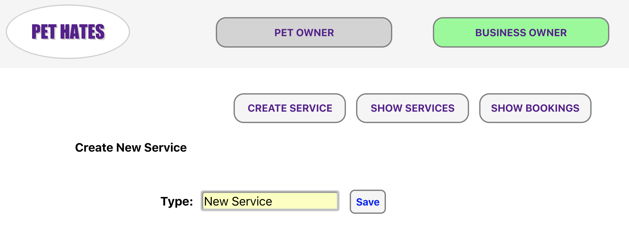

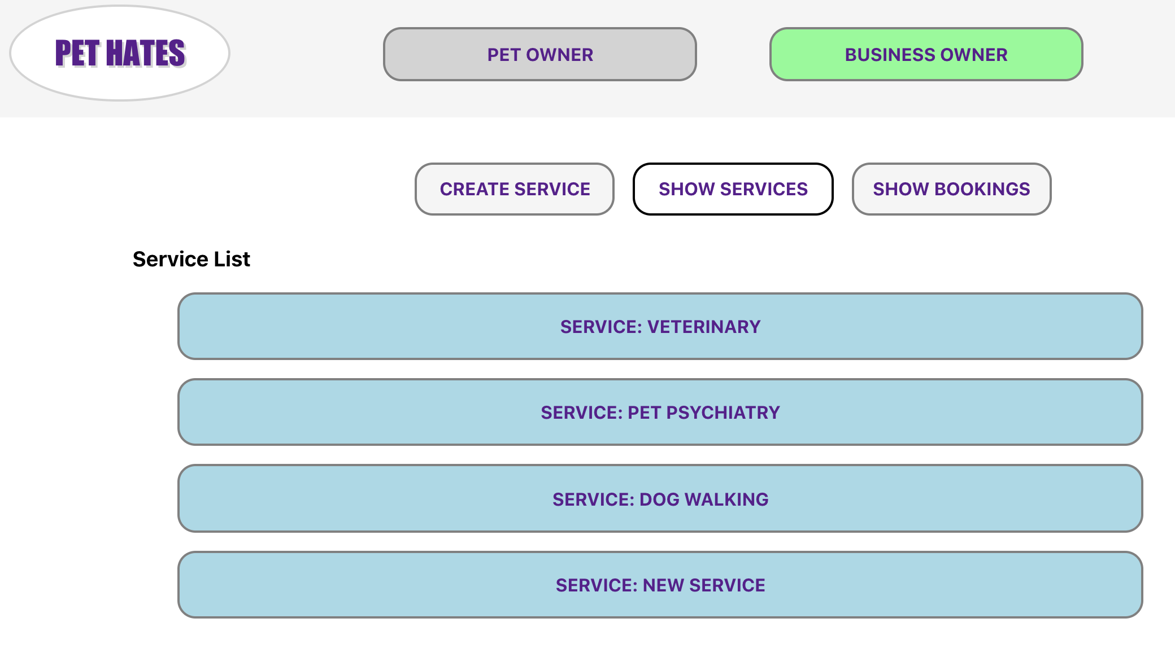

**Description here**

The user performs the action of adding a New Service then checks to see if the New Service was added correctly

| Unit | Ref | Evidence |  |
| --- | --- | --- | --- |
| P | P.11 | Take a screenshot of one of your projects where you have worked alone and attach the Github link. | |
|  |  | **Description:** | |

**Paste Screenshot here**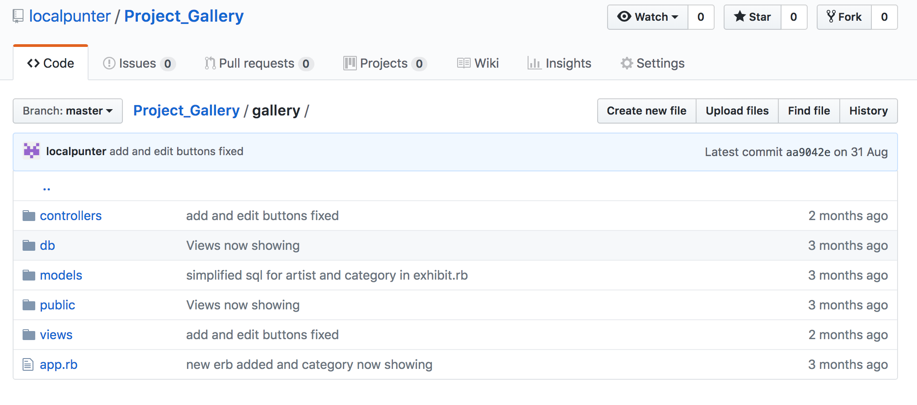

**Link:** https://github.com/localpunter/Project_Gallery/tree/master/gallery

| Unit | Ref | Evidence |  |
| --- | --- | --- | --- |
| P | P.12 | Take screenshots or photos of your planning and the different stages of development to show changes. | |
|  |  | **Description:** | |

**Paste Screenshot here**



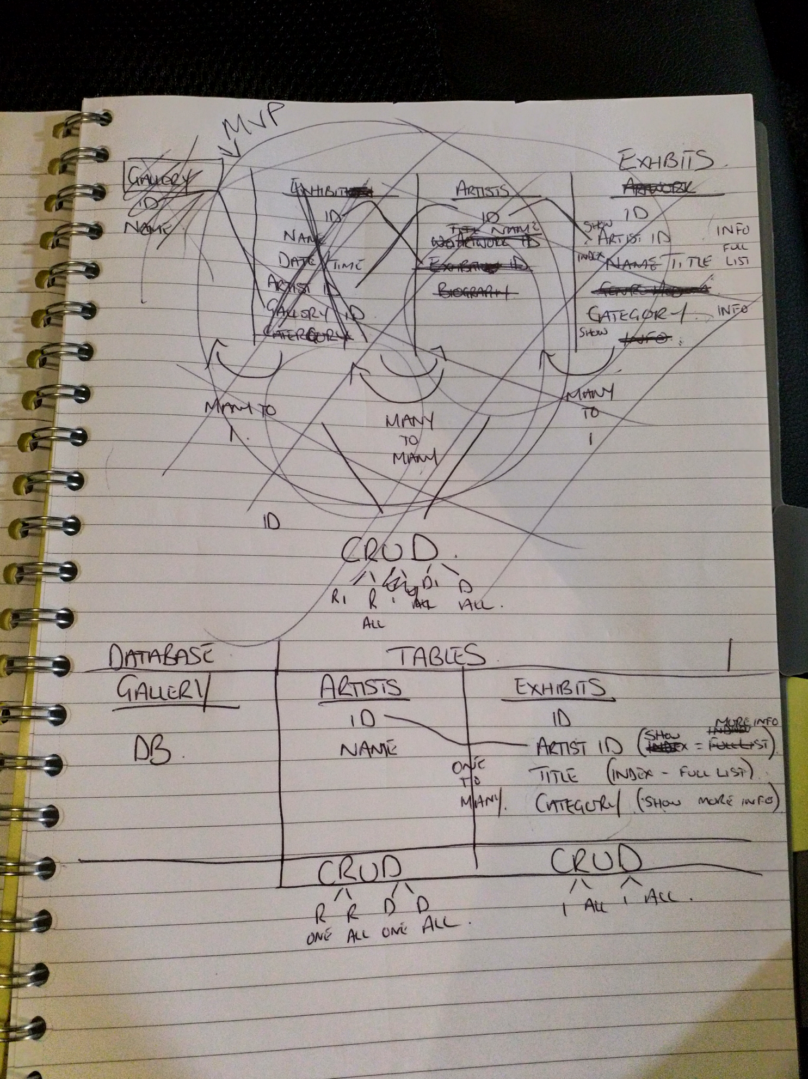

**Description here**

The Case diagram was originally drafted with a forth class ‘Exhibitions’ based but was soon realised that this caused a many to many relationship. After reevaluating the Persona diagrams it was decided that there was no requirement for the Exhibitions class as the Exhibits would take care of that. This led to a re-design of the Class diagram with only 3 classes and no many to many DB relationships.

**Week 7**

| Unit | Ref | Evidence |  |
| --- | --- | --- | --- |
| P | P.16 | Show an API being used within your program. Take a screenshot of:  * The code that uses or implements the API  * The API being used by the program whilst running | |
|  |  | **Description:** | |

**Paste Screenshot here**

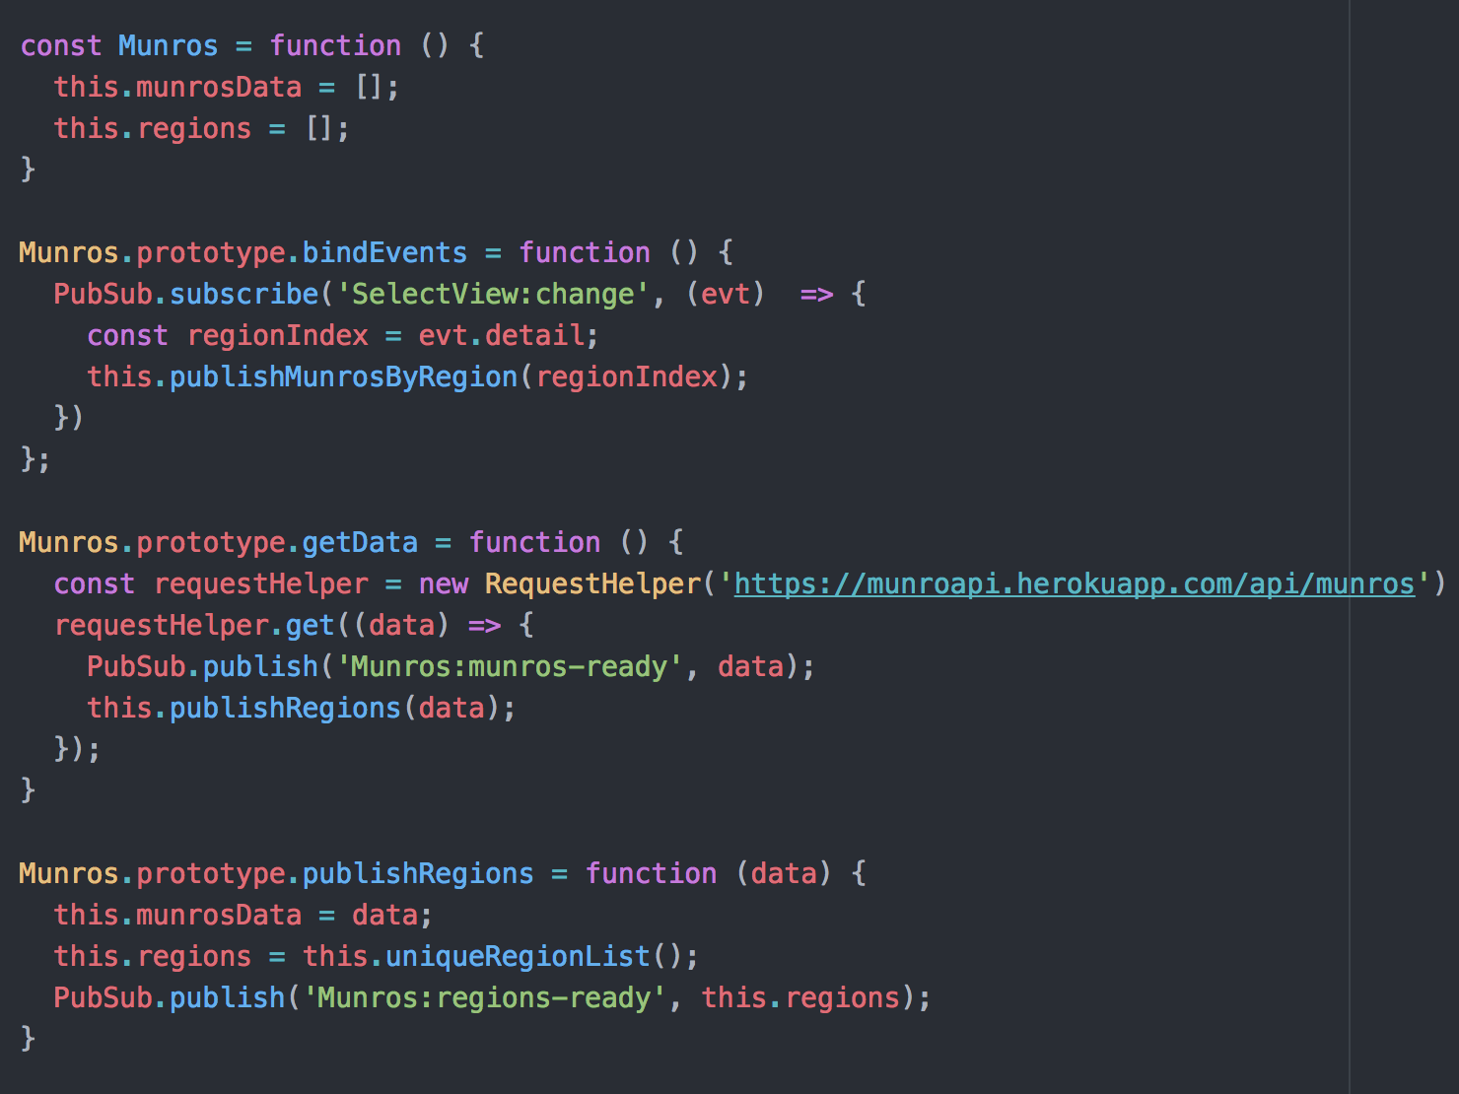

**Description here**

| Unit | Ref | Evidence |  |
| --- | --- | --- | --- |
| P | P.18 | Demonstrate testing in your program. Take screenshots of:  * Example of test code  * The test code failing to pass  * Example of the test code once errors have been corrected  * The test code passing | |
|  |  | **Description:** | |

**Paste Screenshot here**

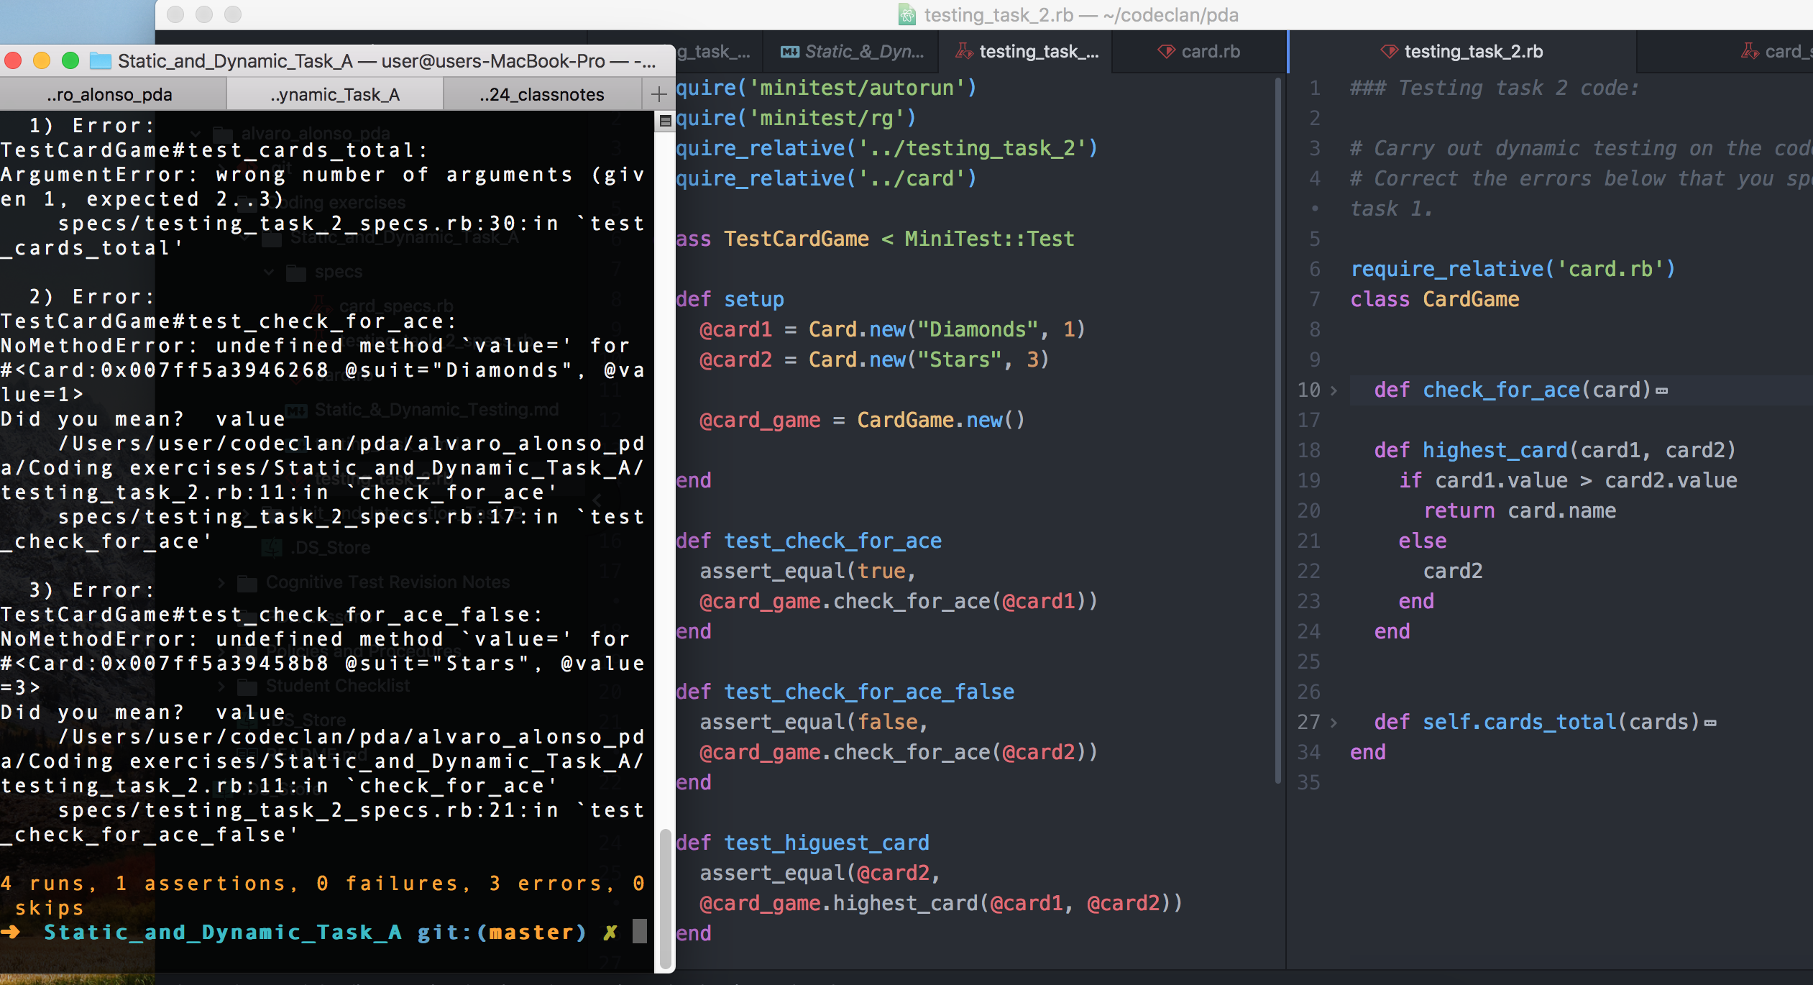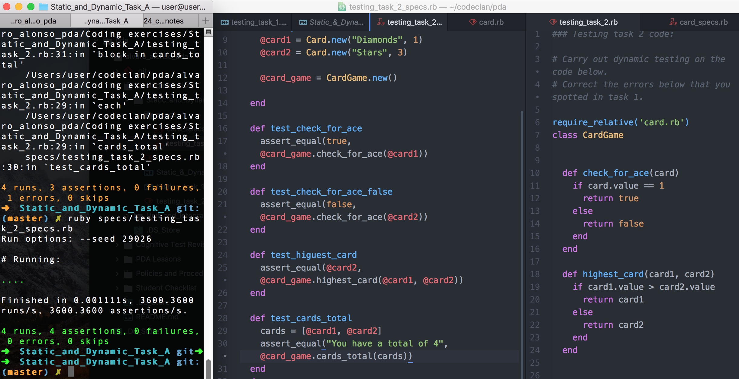

**Description here**

**In the first screenshot we have a class with errors and we write new tests with the expected results. Once the tests are coded we fix the errors in the class.**

**Week 9**

| Unit | Ref | Evidence |  |
| --- | --- | --- | --- |
| P | P.1 | Take a screenshot of the contributor’s page on Github from your group project to show the team you worked with. | |
|  |  | **Description:** | |

**Paste Screenshot here**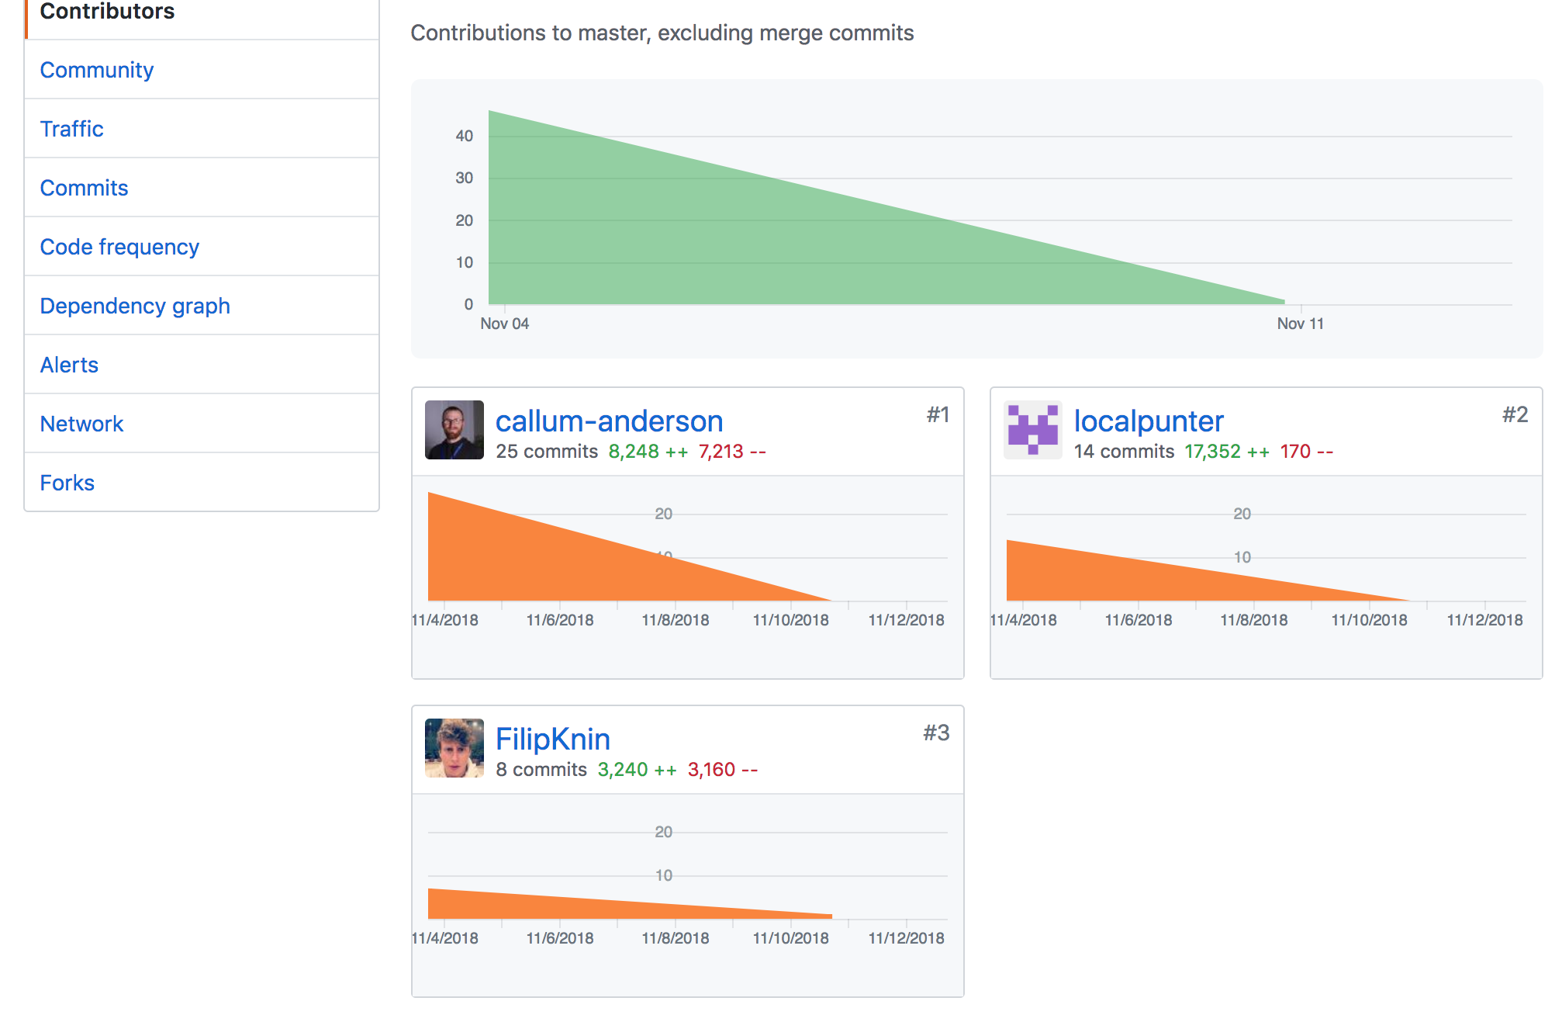

**Description here**

**Contributors screenshot for the Pet app project with 3 team members.**

**Link to Git Repo: https://github.com/localpunter/FullStack_Pet_App**

| Unit | Ref | Evidence |  |
| --- | --- | --- | --- |
| P | P.2 | Take a screenshot of the project brief from your group project. | |
|  |  | **Description:** | |

**Paste Screenshot here**

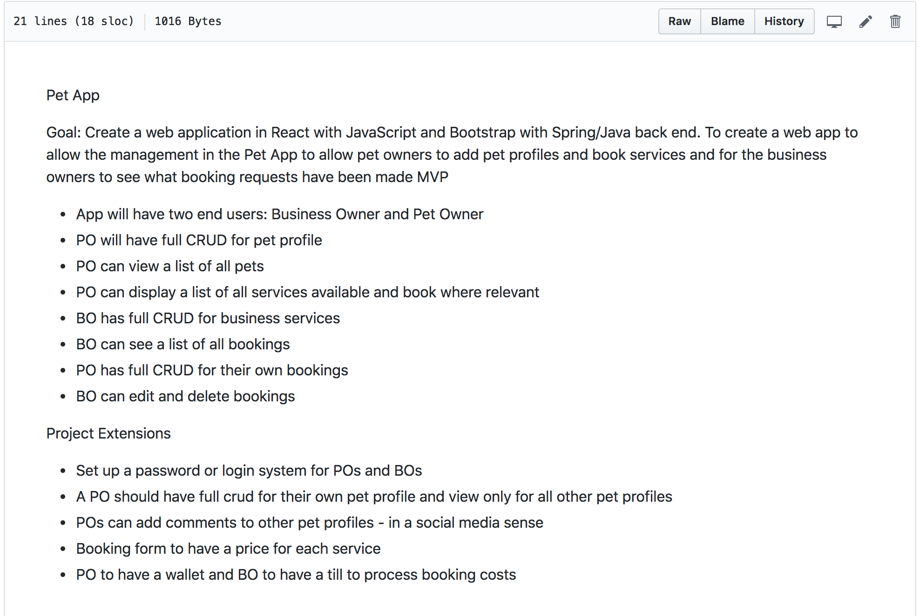

**Description here**

**A screenshot of the project brief for the Pet app group project I work on**

| Unit | Ref | Evidence |  |
| --- | --- | --- | --- |
| P | P.3 | Provide a screenshot of the planning you completed during your group project, e.g. Trello MOSCOW board. | |
|  |  | **Description:** | |

**Paste Screenshot here**

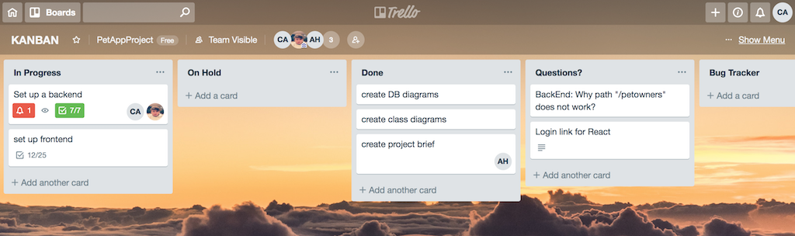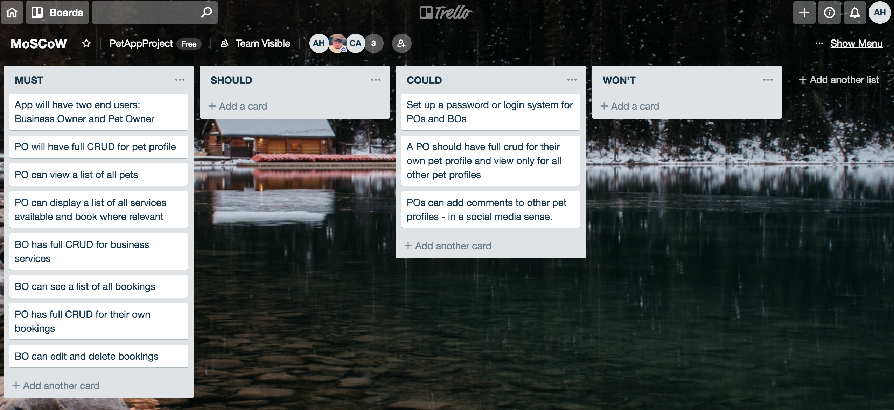

**Description here**

**Moscow and Kanban boards used during the Pet app group project I worked on**

| Unit | Ref | Evidence |  |
| --- | --- | --- | --- |
| P | P.4 | Write an acceptance criteria and test plan. | |
|  |  |  | |

**Paste Screenshot here**

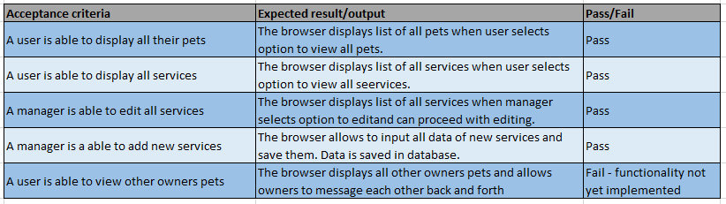

**Description here**

**Screenshot shows acceptance criteria and test plan for pet app**

| Unit | Ref | Evidence |  |
| --- | --- | --- | --- |
| P | P.7 | Produce two system interaction diagrams (sequence and/or collaboration diagrams). | |
|  |  | **Description:** | |

**Paste Screenshot here**

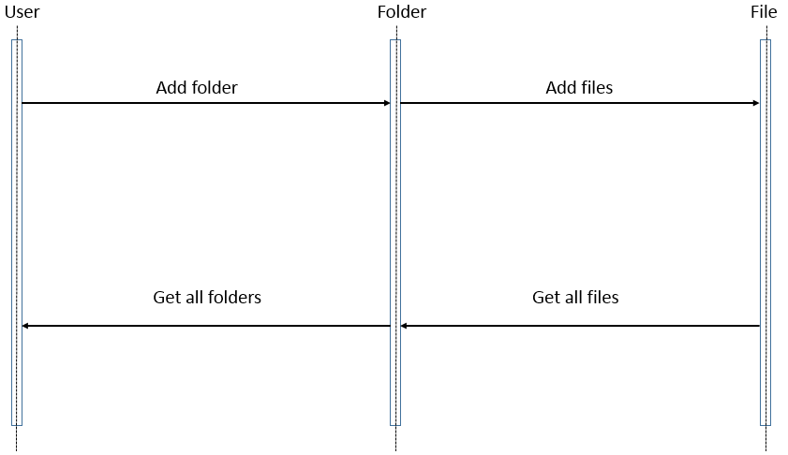

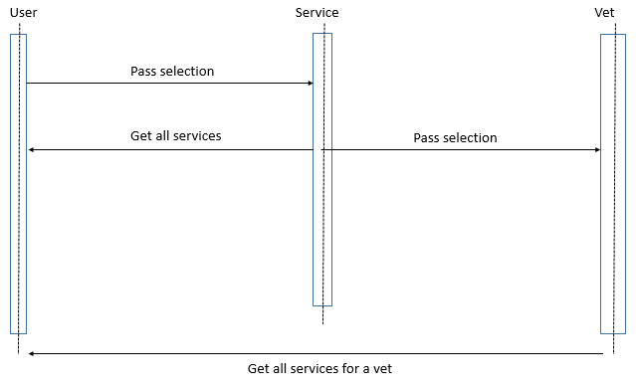

**Description here**

Screenshots show 2 sequence diagrams for a user-folders-files model and a pet app for displaying services, the vet that offers the service and all services offered by the vet.

| Unit | Ref | Evidence |  |
| --- | --- | --- | --- |
| P | P.8 | Produce two object diagrams. | |
|  |  | **Description:** | |

**Paste Screenshot here**

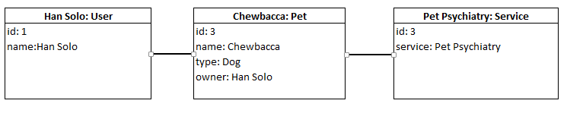

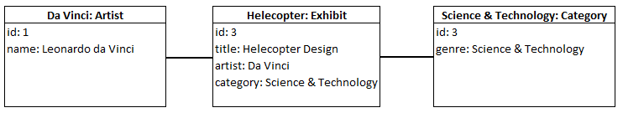

**Description here**

**Object diagrams for the pet app and the museum app**

| Unit | Ref | Evidence |  |
| --- | --- | --- | --- |
| P | P.17 | Produce a bug tracking report | |
|  |  | **Description:** | |

**Paste Screenshot here**

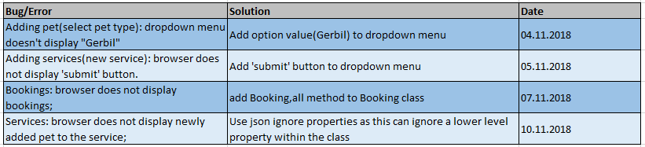

**Description here**

**Bug tracking report for the Pet app**

**Week 12**

| Unit | Ref | Evidence |  |
| --- | --- | --- | --- |
| I&T | I.T.7 | The use of Polymorphism in a program and what it is doing. | |
|  |  | **Description**: | |

**Paste Screenshot here**

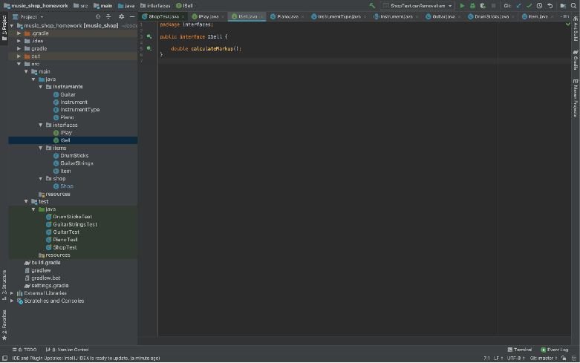

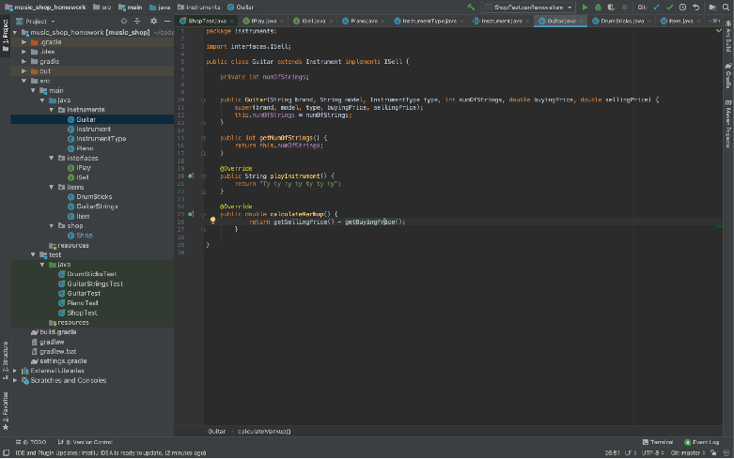

**Description here**

**Screenshots show ISell interface which implements method calculateMarkup**

| Unit | Ref | Evidence |  |
| --- | --- | --- | --- |
| A&D | A.D.5 | An Inheritance Diagram | |
|  |  | **Description:** | |

**Paste Screenshot here**

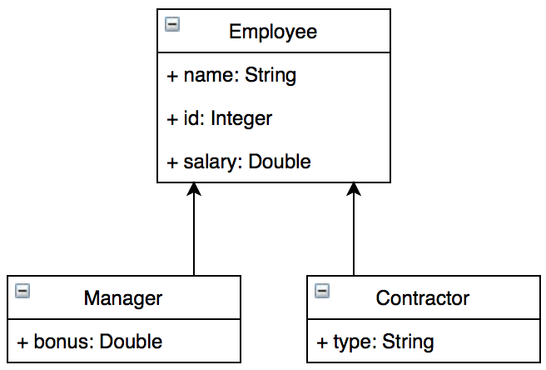

**Description here**

**An inheritance diagram showing an employee class and 2 subclasses – Manager and Contractor.**

**The subclasses inherit the Employee properties – name, id & salary – and add their own properties – bonus (for manager) and type (for contractor)**

| Unit | Ref | Evidence |  |
| --- | --- | --- | --- |
| I&T | I.T.1 | The use of Encapsulation in a program and what it is doing. | |
|  |  | **Description:** | |

**Paste Screenshot here**

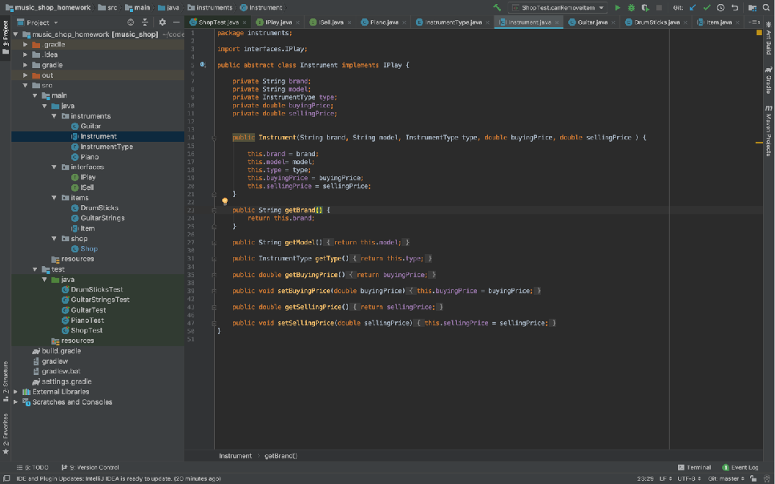

**Description here**

The screenshot shows abstract Instrument Class which has private properties not available outside the class and can be accessed by getters and setters.

| Unit | Ref | Evidence |  |
| --- | --- | --- | --- |
| I&T | I.T.2 | Take a screenshot of the use of Inheritance in a program. Take screenshots of:  *A Class  *A Class that inherits from the previous class  *An Object in the inherited class  *A Method that uses the information inherited from another class. | |
|  |  | **Description:** | |

**Paste Screenshot here**

**Description here**

| Unit | Ref | Evidence |  |
| --- | --- | --- | --- |
| P | P.9 | Select two algorithms you have written (NOT the group project). Take a screenshot of each and write a short statement on why you have chosen to use those algorithms. | |
|  |  | **Description:** | |

**Paste Screenshot here**

**Description here**